EXP NO 1: CREATE A SIMPLE CLOUD SOFTWARE APPLICATION AND PROVIDE IT AS A SERVICE USING ANY CLOUD SERVICE PROVIDER TO DEMONSTRATE SOFTWARE AS A SERVICE (SAAS).

DATE:27-09-2025  
 AIM:  
 To create a simple cloud software application and provide it as a service using any cloud service provider to demonstrate software as a service (saas).

PROCEDURE:   
STEP1: GOTO ZOHO.COM   
STEP 2: LOGIN TO THE ZOHO.COM   
STEP 3: SELECT ONE APPLICATION   
STEP 4: ENTER APPLICATION NAME  
 STEP 5: CREATED NEW APPLICATION   
STEP 6: SELECT ONE FORM  
 STEP 7: THE SOFTWARE HASE BEEN CREATED.

IMPLEMENTATION:

**STEP1: GOTO ZOHO.COM**

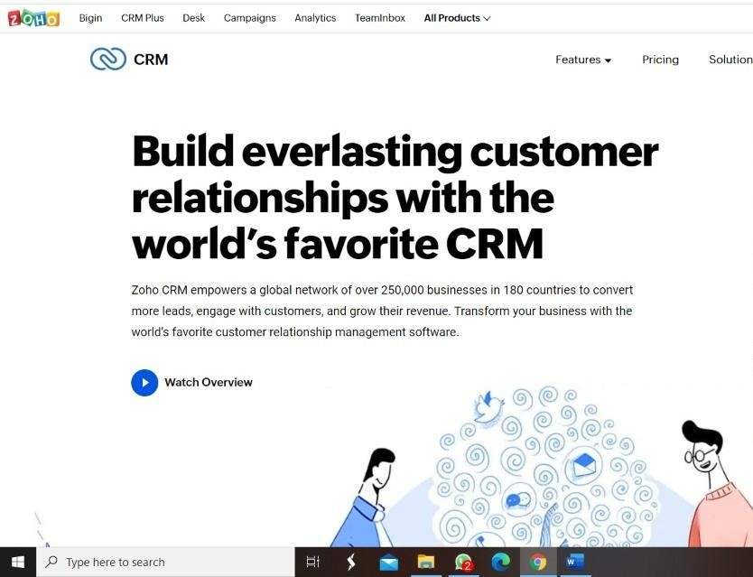

**STEP 2: LOGINTOTHE ZOHO.COM**



**STEP 3: SELECT ONE APPLICATION**

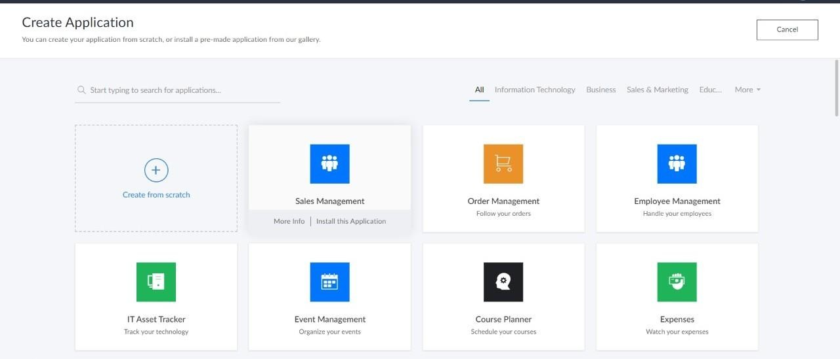

**STEP 4: ENTER APPLICATION NAME**

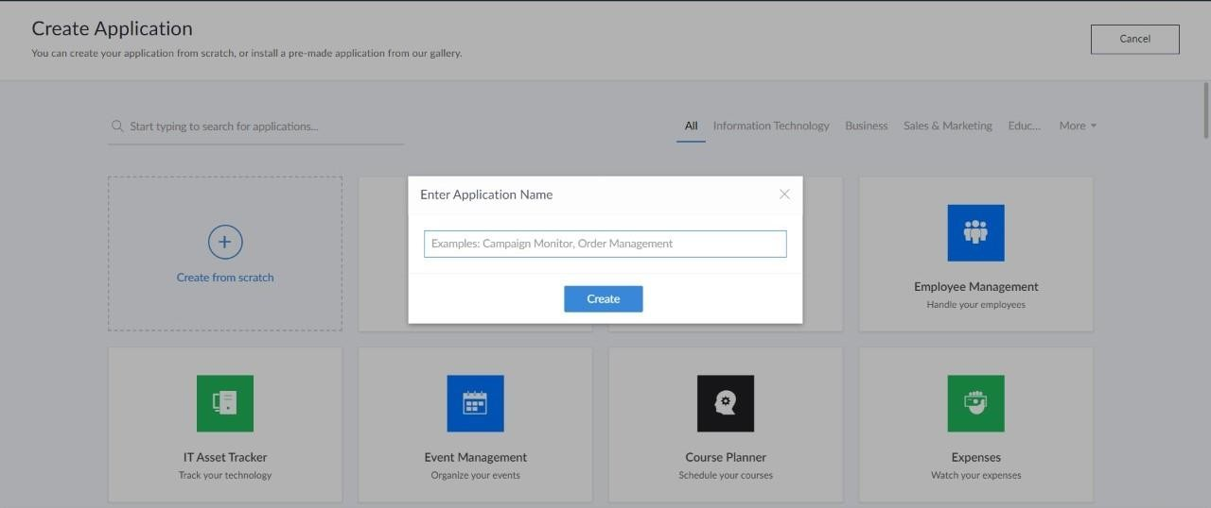v**STEP 5: CREATED NEW APPLICATION**

**STEP 5: CREATED NEW APPLICATION**

STEP 5: CREATED NEW APPLICATION  
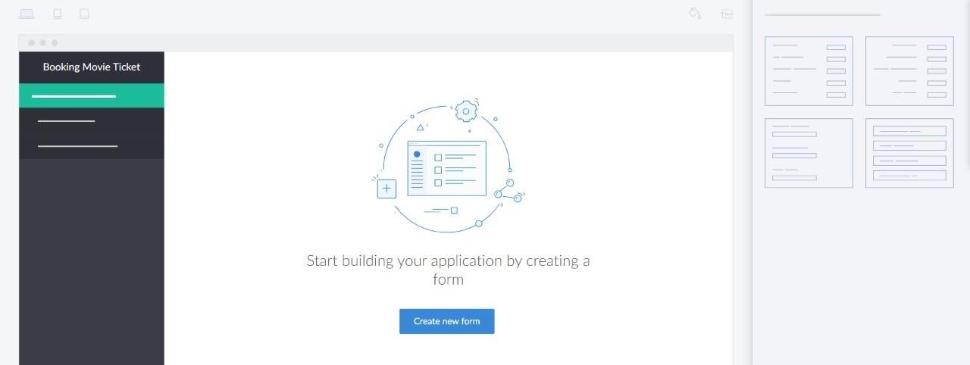

**STEP 6: SELECT ONE FORM**

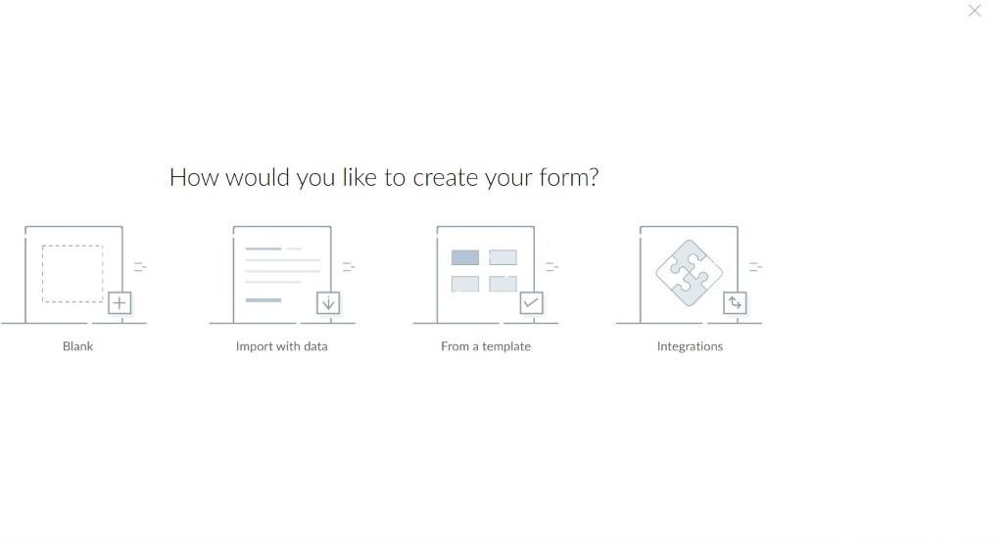

**STEP 7: THE SOFTWARE HASE BEEN CREATED.**

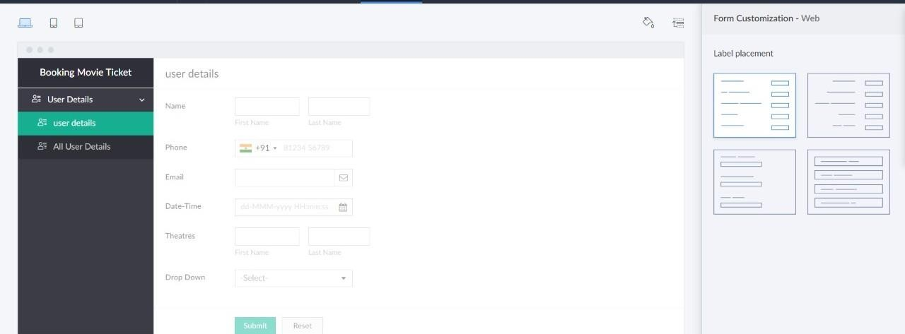

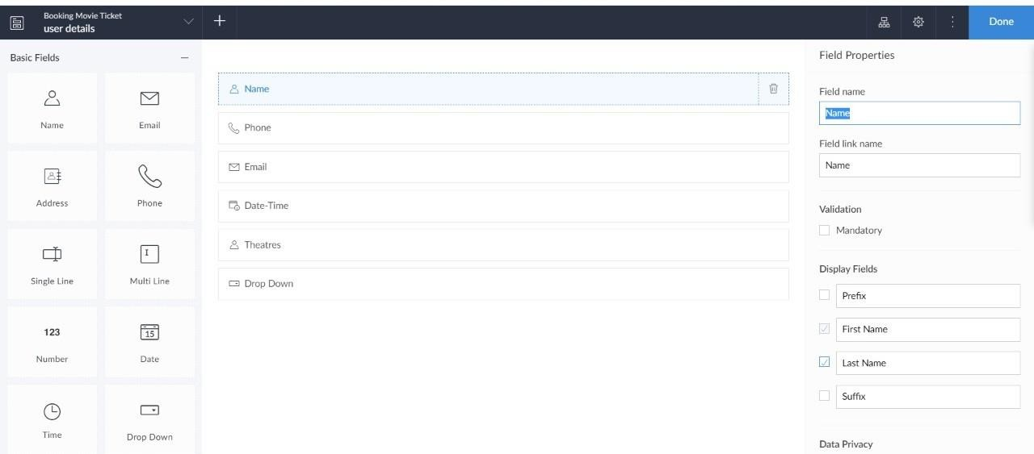

Sample output:

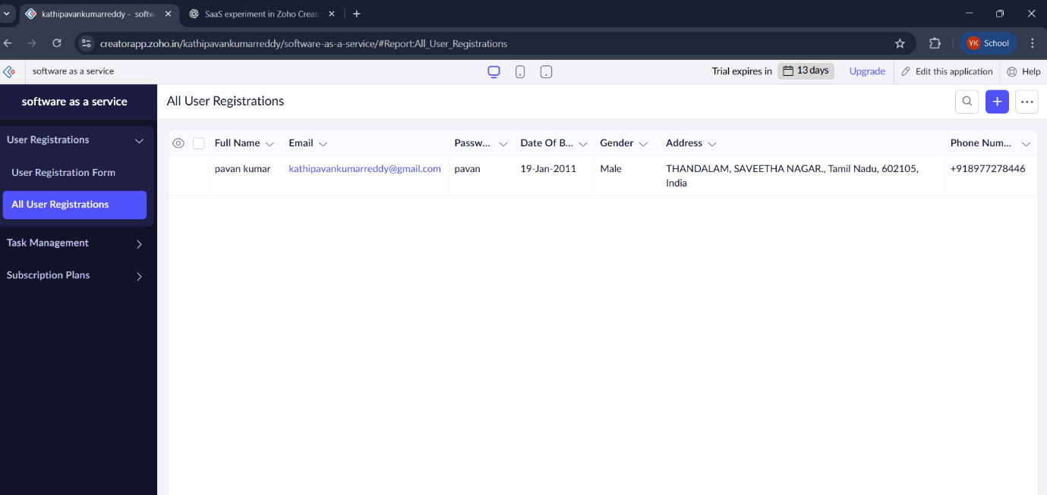User Registration:  
  
  
  
  
  
  
  
  
  
  
Task Management:

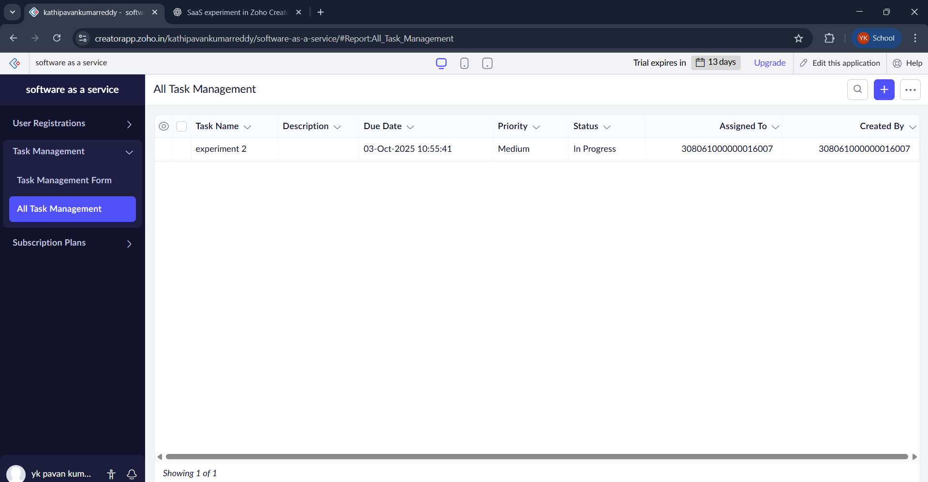

Subscription Plan:

